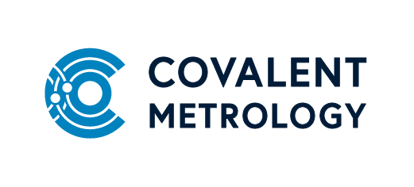

Title: Member of Technical Staff/Sr. MTS, Materials Chemistry
Summary:
Covalent Metrology is seeking an experienced, full time Member of Technical Staff (MTS), Materials Chemistry. You will have the chance to develop new analytical methods on state-of-the-art analytical instrumentation, with an emphasis on materials characterization.
About us:
Covalent Metrology’s mission is to level the playing field and ensure that clients of all sizes have access to outstanding data generated quickly and cost-effectively. High quality experimental data is the lifeblood of any successful commercial R&D program. Too many companies operate blindly without critical data because the proper tool is not available in-house and sending samples out to service labs can be slow, frustrating, and expensive. Data that is generated in-house can be unreliable or imprecise if tools are not properly calibrated, are obsolete, in disrepair or not properly operated.
Covalent’s Analytical Services and Metrology Partners units are open for business and on a mission to provide and enable better, faster, and cheaper data for every client. Covalent now has over 500 customers in 20+ industries and a new 24,000 ft lab in Sunnyvale, CA houses >$10M in state-of-the-art analytical instrumentation.

Duties/Responsibilities:
- Assist the Chemistry Technology Leader as necessary for the day-to-day performance of the Chemistry team.
- Apply the latest technologies in materials characterization and spectroscopy to identify and evaluate the chemical property of materials, including GCMS, FTIR, Raman, NMR, thermal analysis.
- Occasionally assist with related particle and porous material analysis projects in PSA, DLS, and zeta potential.
- Independently design experiments, execute, and interpret data on analytical projects and author technical reports to answer client questions.
- Work with Chemistry Technology Leader to develop and implement novel techniques and capabilities within the group, including new SOP’s and method development as needed for chemical analysis.
- Handle chemicals; prepare samples, calibration and reference standards for analysis, including in glove boxes and chemical fume hoods while maintaining a safe laboratory environment.
- Communicate directly with customers to understand the analysis requirements to assist Sales Engineers in creating statements of work.
- Communicate directly with customers to answer questions after completion of work.

Qualifications:
- MS with 2+ years of related experience or PhD in Chemistry, Materials Science, Physics, or related field.
- Extensive hands-on experience with chemical analysis techniques and statistical data analysis: NMR, GC-MS, Raman, FTIR.
- Prior experience with analytical method development is required.
- Exceptional problem-solving skills, scientific curiosity, the ability to work independently, desire to learn new technologies, adapt and shift focus as needed.
- Clear communication, both written and verbal, with a diverse audience is a critical skill; excellent customer-interfacing skills is a must.
- Evolved gas analysis experience is a plus.
- UV-Vis spectroscopy experience is a plus.

