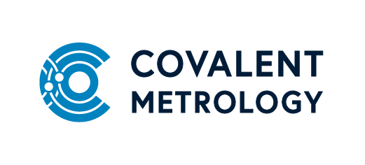

Title: Engineer/Sr. Engineer, Materials Chemistry
Summary:
Covalent Metrology is seeking an experienced, full time Engineer/Sr. Engineer, Materials Chemistry. You will have the chance to develop new analytical methods on state-of-the-art analytical instrumentation, with an emphasis on materials characterization.
About us:
Covalent Metrology’s mission is to level the playing field and ensure that clients of all sizes have access to outstanding data generated quickly and cost-effectively. High quality experimental data is the lifeblood of any successful commercial R&D program. Too many companies operate blindly without critical data because the proper tool is not available in-house and sending samples out to service labs can be slow, frustrating, and expensive. Data that is generated in-house can be unreliable or imprecise if tools are not properly calibrated, are obsolete, in disrepair or not properly operated.
Covalent’s Analytical Services and Metrology Partners units are open for business and on a mission to provide and enable better, faster, and cheaper data for every client. Covalent now has over 500 customers in 20+ industries and a new 24,000 ft lab in Sunnyvale, CA houses >$10M in state-of-the-art analytical instrumentation.

Duties/Responsibilities:
- Initiate and perform chemical analysis projects involving: FTIR, Raman, NMR, GCMS, evolved gas analysis (e.g. TGA-FTIR).
- Occasionally assist with related polymer and materials characterization measurements such as: TGA, DSC, DLS, PSA, BET, gas adsorption porosimetry, zeta potential.
- Create and execute internal SOPs on repeat analytical projects and build technical reports.
- Process characterization data, apply quantification tools and effectively present results.
- Handle chemicals; prepare samples, calibration and reference standards for analysis, including in glove boxes and chemical fume hoods while maintaining a safe laboratory environment.
- Provide continuous feedback to the team on system performance and potential issues; troubleshoot and escalate as necessary to maintain system availability.

Qualifications:
- University degree (BA/BS) with 2+ years of related experience or MS in Chemistry, Materials Science, Physics, or related field.
- General understanding of materials science, chemistry and physics.
- Relevant hands-on experience with materials characterization techniques such as TGA, DSC, DLS, PSA.
- Demonstrated ability for clear verbal and written communication with a diverse audience.
- Customer-focused mindset and interpersonal skills are required.
- Problem-solving skills, the ability to work independently, desire to learn new technologies, adapt and shift focus as needed.
- Experience with porous materials is a plus.

