There seems to be no problem with using the new check valves and also leaving them in place when doing a helium refill to replace the old brass D207 low flow valves which need to be taken off for helium fills. Note that caution is advised and also consultation with Bruker for any changes made to a system. Here is a listing of the check valves:
Z58140, marked as “Nur fur installation” and is colored red (deliberately I guess, though more of a brown to my eyes) and is intended only for magnet installation. I was explicitly told by a Bruker engineer at my previous posting not to use it. Some users have tried these check valves and have been dissatisfied with them and decided not to use them, others have not been satisfied but continue to use them, and still others find them fine and happily use them. It is possible to leave the valve in during helium fills but it is recommended to use low filling pressures to prevent erratic behavior, e.g. 2 psi for narrow bore transfer lines and 1 psi for wider bore transfer lines. Caution is advised and also consultation with Bruker regarding their use. It has KF-25 flange fittings at both ends. It does not have the internal dampening system hence the erratic behavior reported.
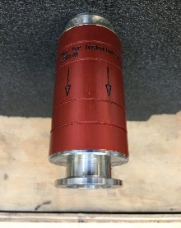

Z52395, this is the standard silver helium check valve (vide infra) with the internal dampening system and screws into the manifold and has a female screw fitting at the exit end (and possibly there may also be versions with a KF-25 flange at the exit end). Cracking pressure of 15 mBar (0.22.5 psi). Pictured is adaptor P/N Z52523: ADAPTER KF25 HE MANIFOLD D2XX which will convert a female screw fitting to a KF-25 flange fitting. Similar adaptors for either converting a female screw fitting to a barb fitting for attaching a tube or converting a KF-25 flange fitting to a barb fitting for attaching a tube exist or can be made in house easily enough. P/Ns unknown.
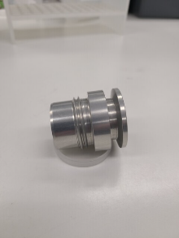

Z178876, this is the helium check valve with the internal dampening system for Oxford magnets and is also colored silver. It has KF-25 flange fittings at both ends. Higher flow valves are also available from Generant (cracking pressure of 10 mBar (0.15 psi) but need a KF-25 to NPT adapter for fitting (available form Loco Science). They are brass and significantly heavier than the valves from Bruker.
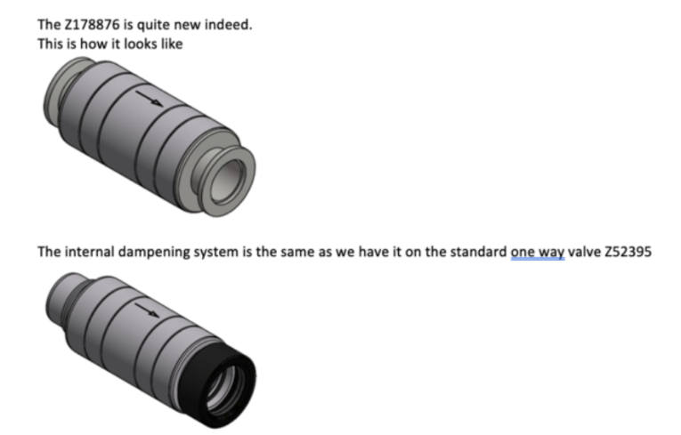

Z52352, this is the mystery valve listed in v2 of the Bruker document "Helium Recovery for NMR Systems" to correct the error in v1 of the Bruker document "Helium Recovery for NMR Systems" which listed the Z58140 check valve.

D107, for posterity’s sake. Cracking pressure of 10 mBar (0.15 psi).
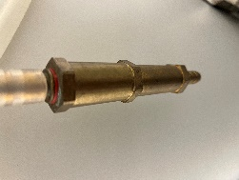

Depending on what the intention and the present setup is (just replace a valve, join up with a helium recovery line etc.), options may include:
1. Join both exit ports up if they are not already joined up and then attach the check valve. It is possible to purchase the whole manifold apparatus from Bruker (P/N Z54230: SET HE MANIFOLD D2XX which includes check valve Z52395 but not the adaptor Z52523: ADAPTER KF25 HE MANIFOLD D2XX, very unclear exactly what is included and what is not) or fashion the manifold attachments in house and just buy the valve.
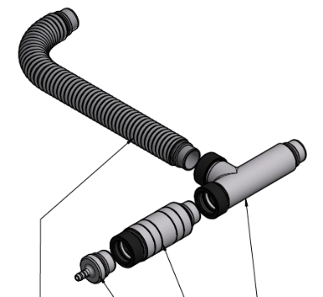
2. Keep the old check valve on one exit port and put a new check valve on the other exit port so as to enable leaving the check valves in place during a helium fill.
3. Put a new check valve on each exit port.

Information collated by Karel Klika with the input from several of the AMMRL community (Peter Dormer, Thomas Smith, Geoffrey Akien, Bob Berno, David Vander Velde, Brian Cherry, John Decatur, Hasan Celik, Mike Lumsden, David Jones, and Margaret Eastman).

